|  |  |  |  |
| --- | --- | --- | --- |
| **Lyng Primary School Knowledge Organiser** | | | |
| **Topic:**  **Romans** | **Escaping from Pompeii**  Why did the landscape of Pompeii make it a dangerous place to live? | Year 3  Battles, beliefs and buildings | Summer Term |

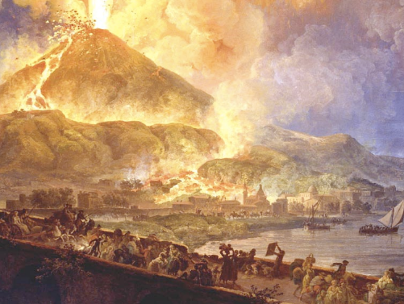

**Background information for parents and teachers**

The city of Pompeii was a major resort city during the times of Ancient Rome. However, in 79 AD, disaster struck the city when it was buried under 20 feet of ash and debris from the eruption of the nearby volcano, Mount Vesuvius. The city of Pompeii was a popular vacation destination for the Romans. It is estimated that between 10,000 and 20,000 people lived in the city. Many wealthy Romans had summer homes in Pompeii and would live there during the hot summer months

|  |  |
| --- | --- |
| **What Step On and Goldilocks words will I use?** | |
| **Spelling** | **Definition** |
| active | An **active** volcano is currently **erupting**, or it has erupted in the **last 10,000 years.** |
| core | The Earth’s **inner core** is a huge **metal** ball, 2,500km wide. Made mainly of iron, the temperature is **5,000°C to 6,000°C.** |
| crust | Earth's **crust** is Earth's **hard outer layer**. It is less than 1% of Earth's volume. |
| dormant | A **dormant** volcano is "**sleeping**," but it **could awaken** in the future. |
| empire | An **empire** is a number of nations that are all controlled by one particular country. |
| eruption | An **eruption** is the **hot rock bursting forth** or out, as of lava from a volcano. |
| extinct | An **extinct** volcano has **not erupted** in the past 10,000 years. |
| lava | **Lava** is the very **hot liquid rock** that comes out of a volcano. |
| magma | **Magma** is the very hot liquid rock that is **inside the volcano.** |
| mantle | Earth's **mantle** is the 1,800 mile (2,900 km) **thick shell** making up about 84% of Earth's volume. |
| volcano | A **volcano** is a **mountain** from which **hot** melted **rock**, gas, steam, and ash from inside the Earth sometimes burst. |

**Fieldwork Opportunities**

Watching the class volcano and writing a description alongside

|  |
| --- |
| **Geographical study** |
| * Identify the different layers of the earth and how this creates volcanoes * Describe a volcanic eruption * Study the events at Pompeii in 79AD * Locate countries in the Roman Empire and how expansive it was. |



|  |
| --- |
| **Enquiry Questions** |
| * How is the earth constructed? * Where are mountains found? * Why and where do we get volcanos? * What are the effects of a volcanic eruption? * What are earthquakes and where do we get them? * How did Mount Vesuvius change the landscape of Pomepii? |

**Significant places**

Pompeii

Italy

Roman Empire

**Our Storytelling Approach to enhance engagement**

|  |  |  |
| --- | --- | --- |
| **People:**  A resident of Pompeii | **Place:**  Pompeii in 79AD | **Problem:**  A volcanic eruption |

**Key facts and locations**

**Map to be studied**

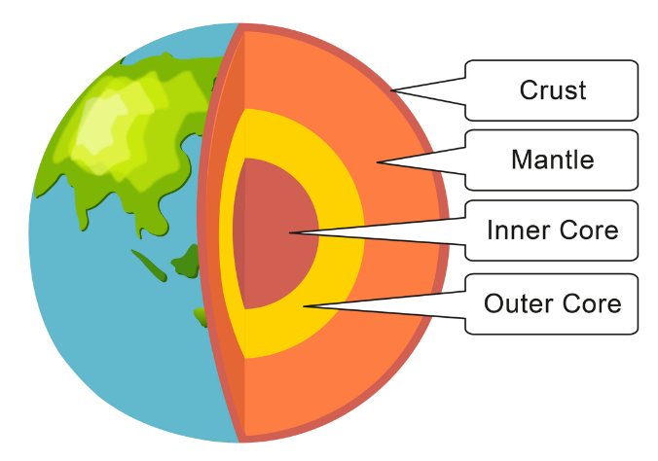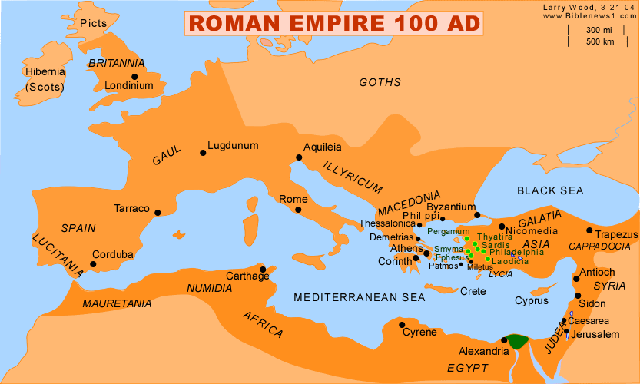

**What happened in 79AD in Pompeii?**

The area around Pompeii experienced frequent earthquakes. In 62 AD there was a huge earthquake that destroyed many of the buildings of Pompeii. The city was still rebuilding seventeen years later when disaster struck.   
  
On August 24, 79 AD Mount Vesuvius erupted. Scientists estimate that 1.5 million tons of ash and rock shot out of the volcano every second. The ash cloud likely towered over 20 miles high above the mountain. Some people managed to escape, but most didn't. It is estimated that 16,000 people died. Even when they first saw smoke rising from the top of the mountain, they were merely curious. They had no idea what was coming until it was too late.  
  
The city of Pompeii was buried and gone. People eventually forgot about it. It wasn't discovered again until the 1700s when archaeologists began to uncover the city. They found something amazing. Much of the city was preserved under the ashes. Buildings, paintings, houses, and workshops that would never have survived all these years remained intact. As a result, much of what we know about everyday life in the Roman Empire comes from Pompeii.

**What causes a volcanic eruption?**

A volcano is an opening in Earth’s crust. When a volcano erupts, hot gases and melted rock from deep within Earth find their way up to the surface. This material may flow slowly out of a fissure, or crack, in the ground, or it may explode suddenly into the air. Volcanic eruptions may be very destructive. But they also create new landforms. There are more than 1,500 potentially active volcanoes in the world today.

**Agreed Outcome**

Volcano experiment and labelled diagram

|  |  |  |  |
| --- | --- | --- | --- |
| **Lyng Primary School Knowledge Organiser** | | | |
| Topic:  Romans | **Escaping from Pompeii**  Why did the landscape of Pompeii make it a dangerous place to live? | Year 3  Battles, beliefs and buildings | Summer Term |

|  |  |  |
| --- | --- | --- |
| What does it mean when a volcano is extinct? | **S** | **E** |
| It is erupting. |  |  |
| It will erupt in a week. |  |  |
| It will not erupt again. |  |  |

|  |  |  |
| --- | --- | --- |
| What is the capital city of Italy? | **S** | **E** |
| London. |  |  |
| Cairo. |  |  |
| Rome. |  |  |

|  |
| --- |
| In which continent is Italy? |
| S E |

|  |  |  |
| --- | --- | --- |
| A volcano has a magma chamber. | **S** | **E** |
|  | True  False | True  False |

|  |  |  |
| --- | --- | --- |
| When did the eruption happen at Pompeii? | **S** | **E** |
| 79AD |  |  |
| 79BC |  |  |
| 1979 |  |  |

|  |  |  |
| --- | --- | --- |
| What is the name of a volcano that is “sleeping”? | **S** | **E** |
| extinct |  |  |
| dormant |  |  |
| active |  |  |

|  |
| --- |
| Name a part of a volcano. |
| S E |

**What was your score?**

Start –

End -

|  |  |  |
| --- | --- | --- |
| The Romans invaded Britain. | **S** | **E** |
|  | True  False | True  False |

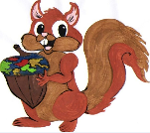

|  |  |  |
| --- | --- | --- |
| Which volcano buried the ancient town of Pompeii in Italy? | **S** | **E** |
| Mount Etna |  |  |
| Mount Vesuvius |  |  |
| Mount Everest |  |  |